**GAME DESIGN DOCUMENT**

CYBERCOLOR

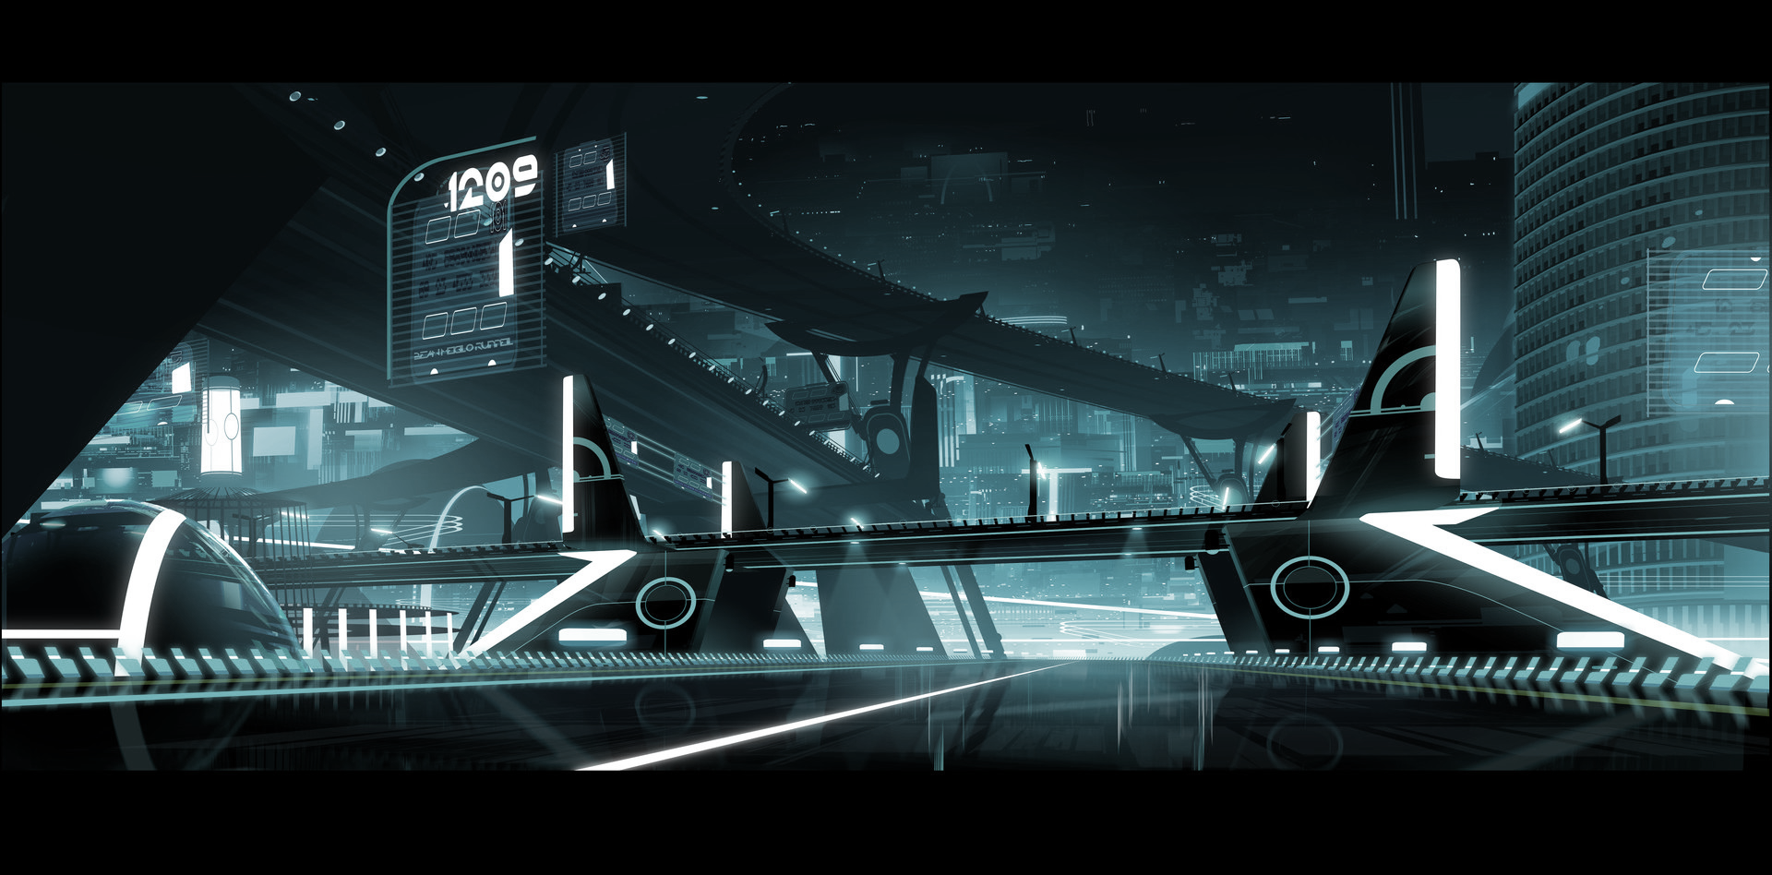

**Prepared By:**

David Guggenberger, Dohnalek Raphael, Markus Duskanich, Michael Duskanich, Alexander Kramreiter

**Last Updated:**

24-Jun-2022

**TABLE OF CONTENTS**

Game Analysis 3

Mission Statement 3

Genre 3

Platforms 3

Target Audience 3

Gameplay 5

Overview of Gameplay 5

Player Experience 5

Gameplay Guidelines 5

Game Objectives & Rewards 5

Gameplay Mechanics 5

Level Design 7

Control Scheme 9

Game Aesthetics & User Interface 9

Schedule & Tasks 12

# Noteworthy Links:

[Repository](https://github.com/MichaelDusk2361/GAME_Project)  
[WebGLBuild](https://play.unity.com/mg/other/webgl-builds-207501)

# Game Analysis

In Cybercolor, four players fight in a top-down free for all by trying to color in the largest area. Heavily inspired by Splatoon, Cybercolor differentiates itself by its arcade-y playstyle, and a Tron-inspired aesthetic.



# Mission Statement

Cybercolor offers a unique local multiplayer experience: fast-paced, arcade-y, and an original setting that blends the classic TRON style with Splatoon core mechanics. Game mechanics might seem simple but are yet hard to master.

# Genre

Top-down Action Shooter, Single-screen, 4-player Local Multiplayer, Arcade-Minigame

# Platforms

WebGL, PC

# Development Environment

Unity URP, GIT+LFS

# Target Audience

Cybercolor targets a broad audience, your casual gamer, as well as competitive friends. This game is best enjoyed in local 4-player multiplayer.

# Gameplay

## Overview of Gameplay

This Game is mainly inspired by Splatoon’s core mechanic, of spreading color over the map, and using the surface area of the team’s color to determine the winner.

In this case, each player would have their own color. A player has a trail of color running behind them, coloring in the area. Players can override each other colors. Furthermore, everyone can charge a projectile that stuns & knocks back other players when hit. This won’t have a cooldown, although it will slow down the charging player considerably. Players should also have a mobility ability (i.e., a dash on a cooldown, may not spread color while dashing).

Due to the top-down nature, any map elevation is discouraged. Ammunition, and player classes were considered, but the decision was made to not implement them, as it would make the game too complicated for a simple arcade-like minigame.

## Player Experience

As a player of Cybercolor, it is easy to get started. All the information you need is on the (only) screen. Sharing the same screen with your (up to 3) competitors, you are in for a classic couch gaming experience.

While the game might start calmly, running around to expand your color, it will quickly devolve into heated combat after you cross your territories.

## Gameplay Guidelines

Cybercolor will adhere to the [USK 6 guidelines](https://usk.de/en/the-usk/faqs/age-categories/).

## Game Objectives & Rewards

This is where you present more details on how the gameplay will motivate the player to progress through the game. Discuss rewards and penalties and the difficulty level. You can use the table below to help break down objectives and rewards.

|  |  |
| --- | --- |
| Rewards | Penalties |
| Larger colored surface  Points in the parent game | Stuns  Knockbacks  Loosing colored surface  Less points awarded in the parent game |

## Gameplay Mechanics

|  |  |
| --- | --- |
| **Character Attributes** |  |
| **Character** | **Movement Abilities / Actions Available** |
| Player | **Coloring Trail**  A coloring trail running behind every player, coloring in the map.  **Chargeable Projectile**  A projectile, which can be charged by holding a button. On release, it fires - stunning and knocking back other players on direct impact. Wherever it impacts, it creates an area of color. A player may get disrupted during charging (i.e., through another projectile). Charging also slows players down considerably, which impacts their coloring rate.  **Dash**  Might be on a long cooldown - or a short cooldown but disabling the coloring trail while dashing. |
| **Game Modes** |  |
| Free for All | **Objective**  Every player has their own color, trying to create the *largest* *accumulation* *of color*.  **Hazards**  As space is limited, *players* will compete for new territory. Every player has tools for sabotaging each other, like a charged projectile that stuns and knockbacks on hit.  *Gaps* in the floor will cause you to be stunned for a short duration if you happen to fall in. |
| **Scoring System** |  |
| **Points/Coins/Stars/Grades/Etc.** | **How it’s Awarded & Benefits** |
| Color surface | Mainly running around and shooting. The higher the surface area, the higher your placing, the higher you rewarded score. |

## Level Design

Figure 1 shows an example of what the level could look like and will most likely share elements with the final game.

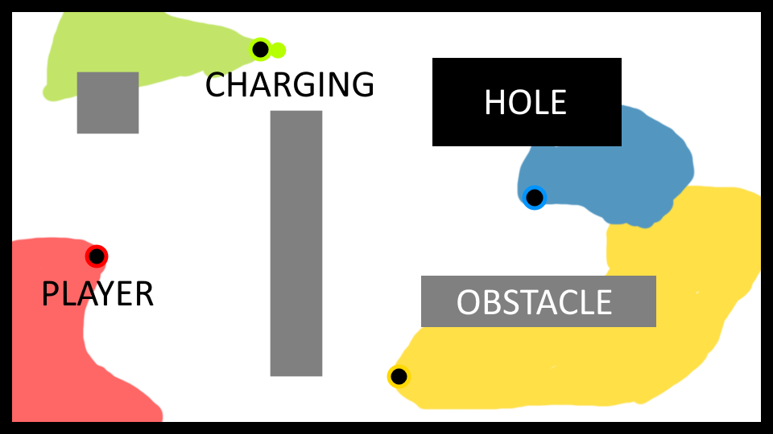

Figure A mockup of a level

Here are some of the 7 levels that are currently in-game. The majority were kept symmetric in order to keep balance with spawning positions.

 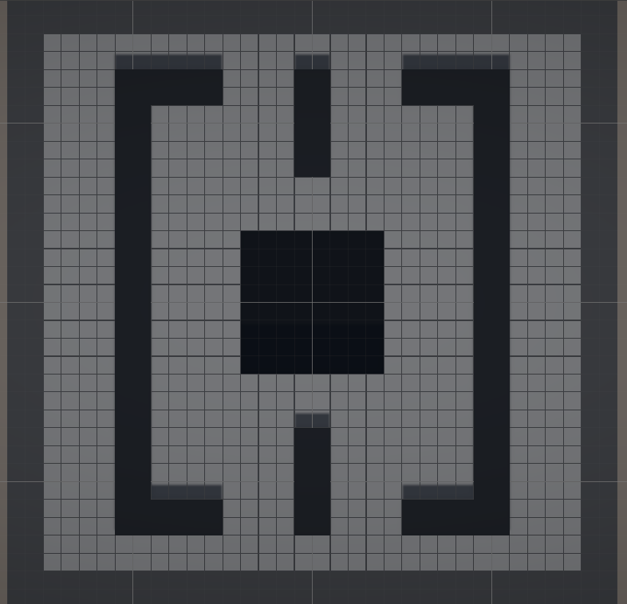

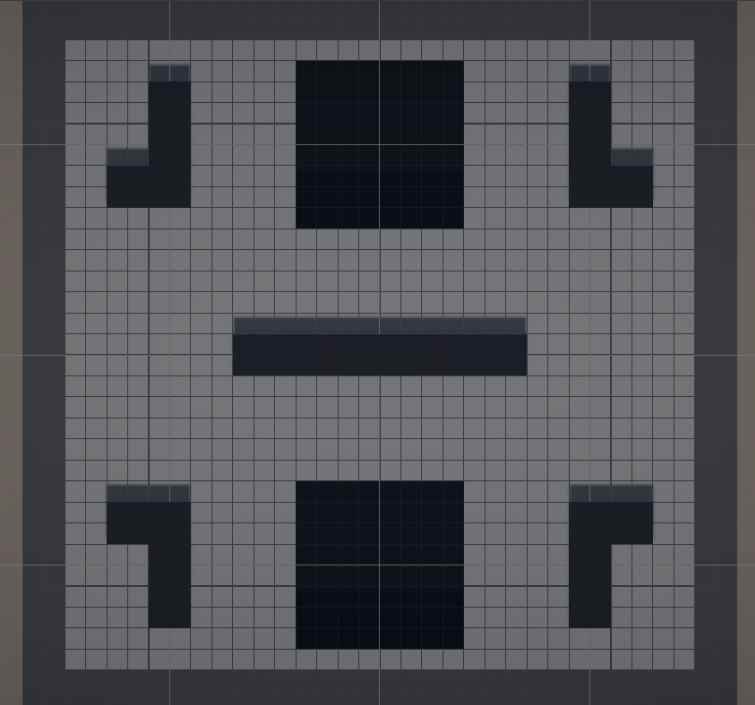 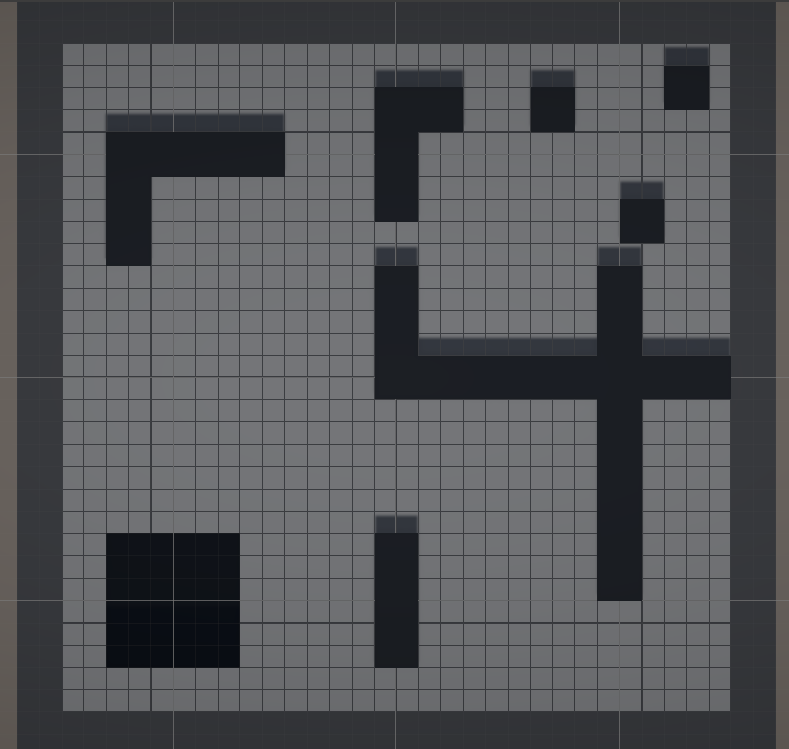

# Control Scheme

Describe the control setup for the game. Does your game use touch input, a controller, or mouse & keyboard? Discuss the functionality of each button/touch. It may help to insert a diagram/pic to help explain the actions.

|  |  |
| --- | --- |
| **Button/ Touch Input** | **Action, it Performs** |
| Left stick | move |
| Right stick | aim charged projectile |
| LB | dash |
| RB | charge |

# Game Aesthetics & User Interface

The anticipated theme for Cybercolor is a Tron inspired art-style. The game will be top-down and will only take place on a single screen. Following are some inspiring images.

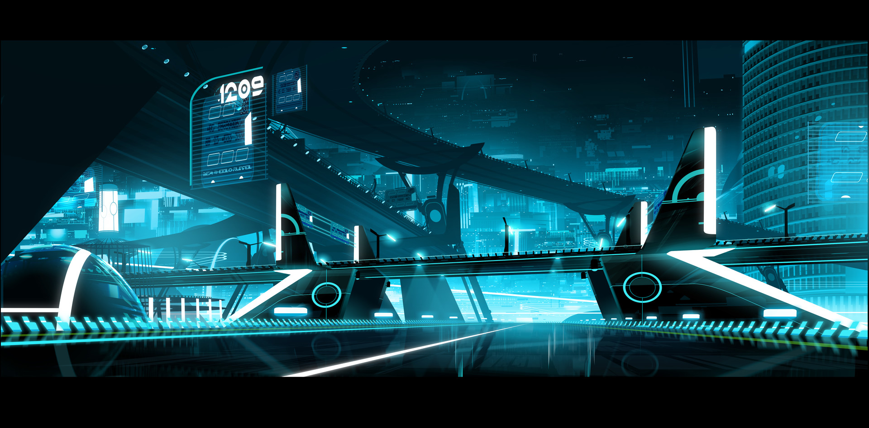

Figure <https://www.artstation.com/artwork/L2eqWw>

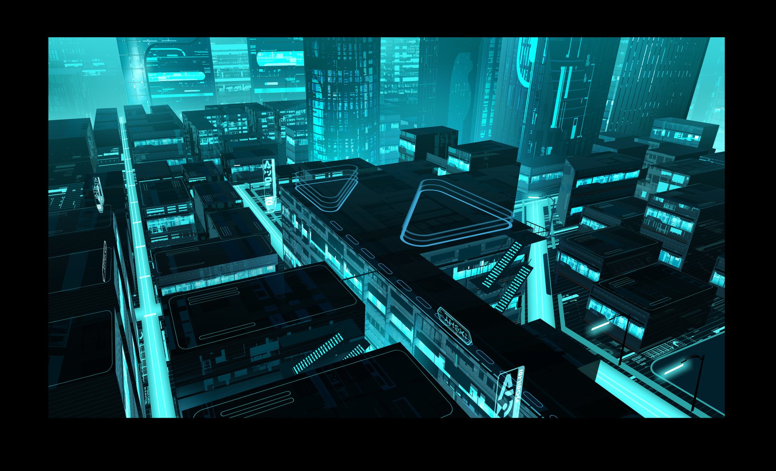

Figure <https://www.artstation.com/artwork/L2eqWw>

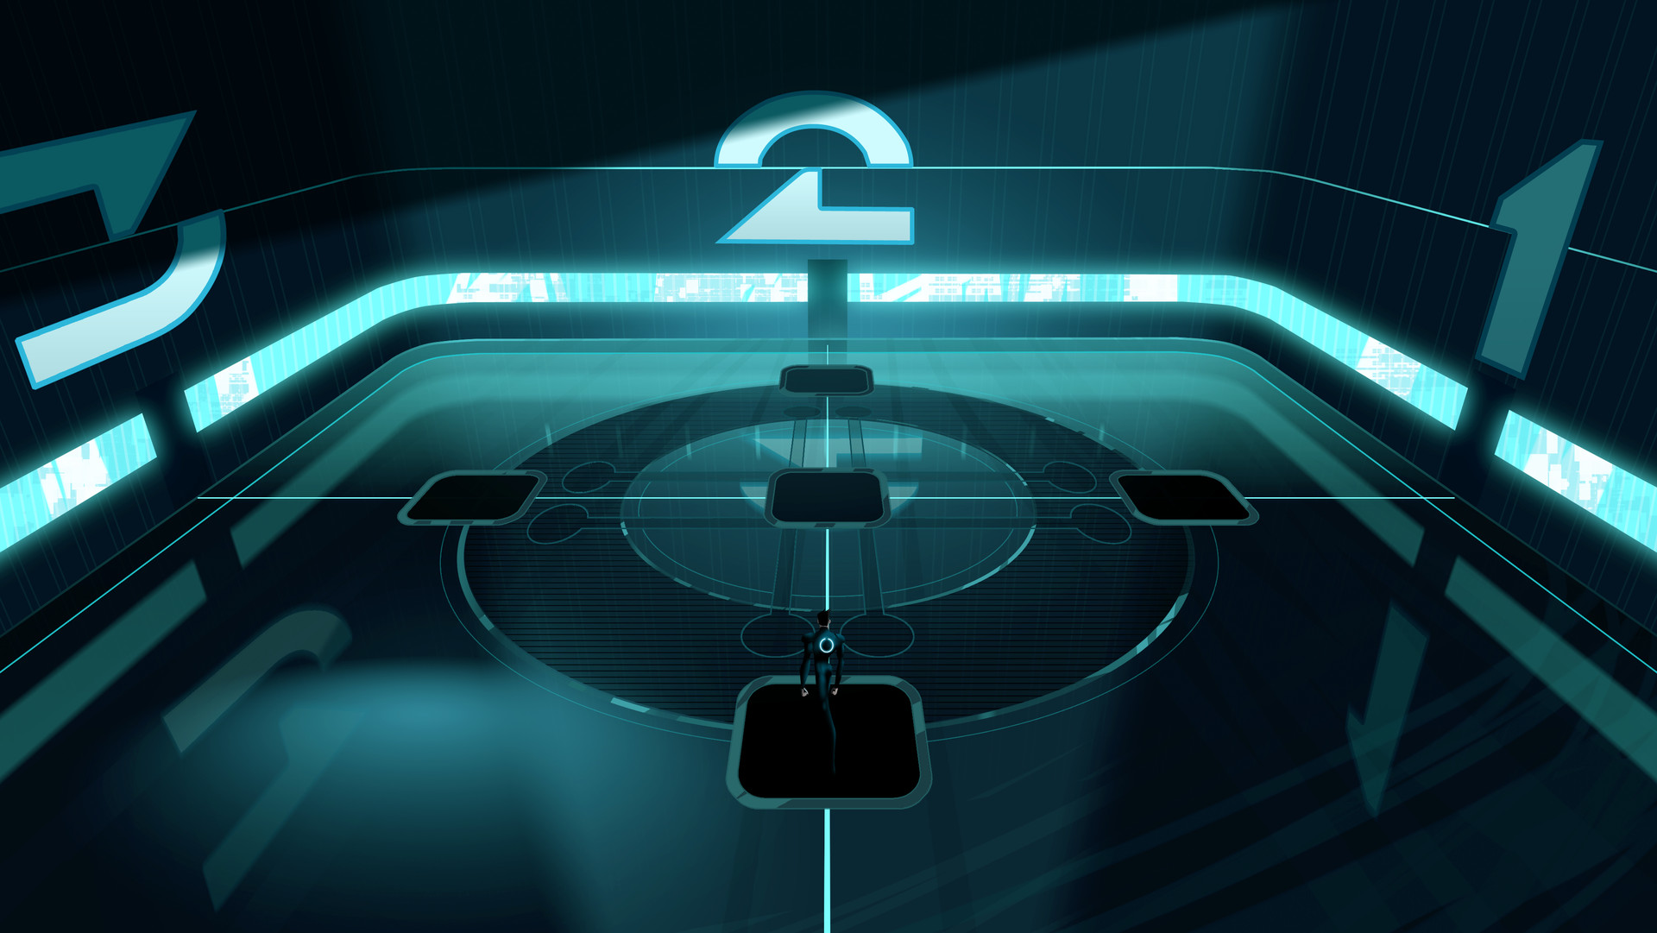

Figure <https://www.artstation.com/artwork/L2eqWw>

The UI will follow in a similar theme. It includes a shared progress bar noting each player’s owned surface area size, as well as unclaimed area size.



Figure Conceptual representation of the space distribution



Figure 6 Final look of the game

# Schedule & Tasks

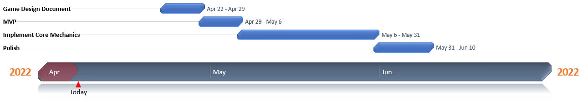

For detailed Tasks, see [DAGoPERT_GAME.xlsx](https://github.com/MichaelDusk2361/GAME_Project/blob/main/DAGoPERT_GAME.xlsx) in our repository.

# Further References

[Splatoon - Painting Effect in Unity](https://www.youtube.com/watch?v=YUWfHX_ZNCw&t=0st)

[Splatoon Ink Effect](https://github.com/mixandjam/Splatoon-Ink)

[Repository](https://github.com/MichaelDusk2361/GAME_Project)

[WebGLBuild](https://play.unity.com/mg/other/webgl-builds-207501)